Computer Programming Using Python 2.7 - **Pygame 4** - **Making Your Own Sprites**

**Due Wed, Mar 6**

GOALS: Create a sprite and use it as the non-player character.

*Remember what Sprites are? They are images for characters like Mario that have no rectangle border—their background is transparent.*

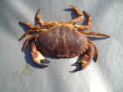**Create a sprite from a picture**:

In Photoshop (or for free at home, GIMP), you can make a sprite. Instructions for doing this in Photoshop are below.

BONUS: Draw your own NPC (must have body and enough parts to look like it can walk or move, and must be filled in).

* First **find an image** then copy it to the clipboard (if on internet, click on full sized image, right-click image then click Copy):

Sites for freely-licensed images: **public-domain-image.com**, morguefile.com

|  |  |
| --- | --- |
| * Start, All Programs, Adobe Design Premium CS, **Adobe Photoshop** CS, Click File, New, then for Preset choose: “**Clipboard**”   Background Contents: **Transparent**  Click **OK**  *If you don’t see the checkerboard representing which parts of the image are see-through, you probably made the background white, so delete the background layer (click it on the LAYERS list on the right, then push the delete key)* | * Click Edit, **Paste**: |

* 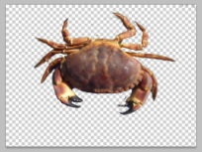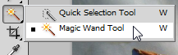On the left tool panel, choose the Eraser , then erase everything in the layer you pasted except the object (for example, erase the ground around a crab so that everything but the crab is erased to show checkerboard). *TIP: A way to make this easier is to use the magic wand tool on parts you don’t want, then press delete on keyboard, then erase any part of background leftover:*

*TIP: To get a part back, hit Edit, Step Backward (in PhotoShop, Undo only goes back one step, so use Step Backward to go farther).*

* Now Make crop the image to reduce the amount of empty space in the image (this will make hit detection easier in your game):
  + Click the Rectangular Marquee (selection) tool 
  + Draw a box around just the part of the image that has your character:

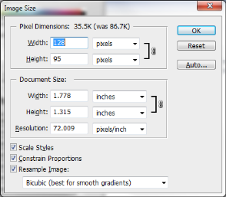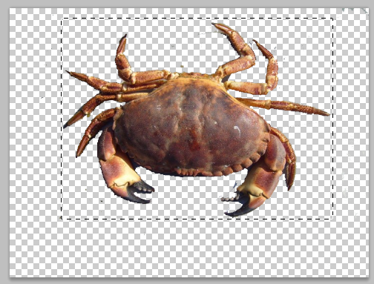

* + On the menu bar at the top, click “Image”, “Crop”. Now your image should be cropped:

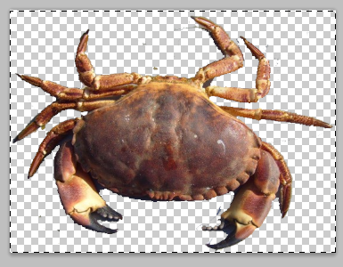

* Now don’t forget, your character has to fit on the screen. Most computer screens made in the year 2013 are 1024x768 or 1920x1080. So, resize image: On the menu bar at the top, click Image, Image Size, (For Dimensions make sure that Pixels is chosen, & at bottom make sure Constrain Proportions is checked), & change **width to 128** (see picture).
* **Save As**, changeFormat to **PNG** **(*.png),** then **Choose H:\bin,** thenname your image file (remember what you named it),then **Save** A sprite will have to be PNG or another format that allows transparency. *TIP:* *A JPG doesn't allow transparency (it doesn't include an alpha channel)--it will always have a rectangle around it. If you make your own Sprite, make sure your background is erased so that the checkerboard test pattern shows through around the object, then save it as PNG.*

**Use the new image as your npc’s image** (BONUS: make the program do something other than move and push)**:**

(you must have Pygame 3 done for these instructions to work)

* Open IDLE
* File, Open, H:\bin\push.pyw
* Find this part in your code (you already should have added it in Pygame 3) and **change the part in quotes to the image file name that you typed above** when you saved the image, including the **.png** at the end of the name, all inside the quotes:

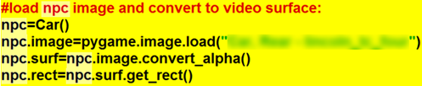

Now Run, Run Module, and your Non-Player Character should be a **different character** than your player!